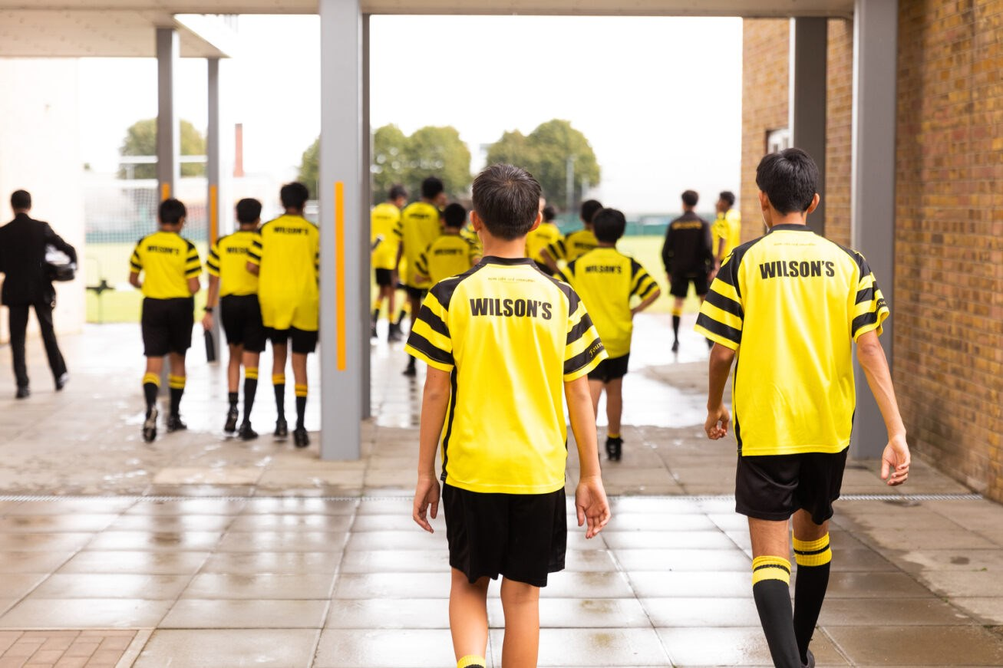
Wolf Salient | 7th Issue
Termly E-news for Wilson's Alumni | December 2023

In This Issue
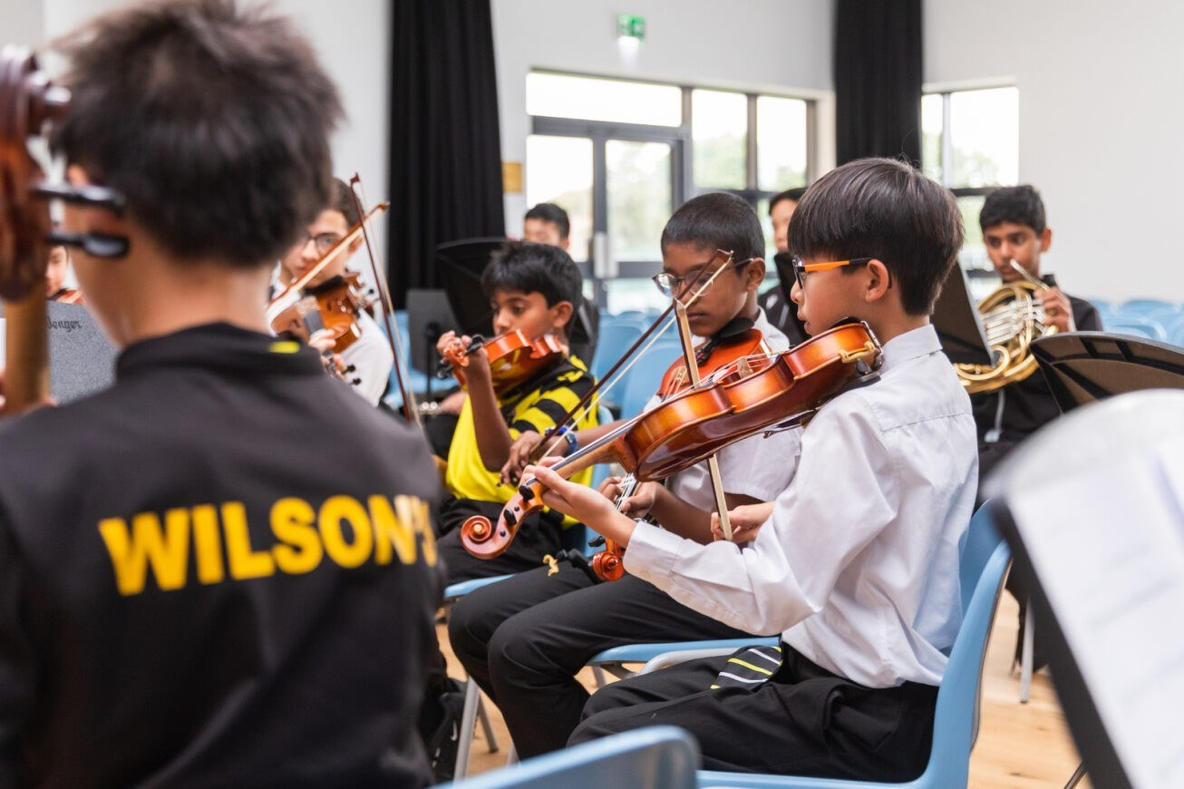
We've gathered the best news related to the school, our alumni, and the Development Office across the last term at Wilson's.
Since June 2023, highlights include:
- Wilson's awarded Secondary School of the Year 2024
- An Old Wilsonian becoming a World Champion Triathlete
- The inauguration of the Benjamin Room in our new Wellbeing Centre
- A Wilson's boy winning at Wimbledon
For all these stories - and more - read on!

Wilson's awarded "Secondary School of the Year 2024"!
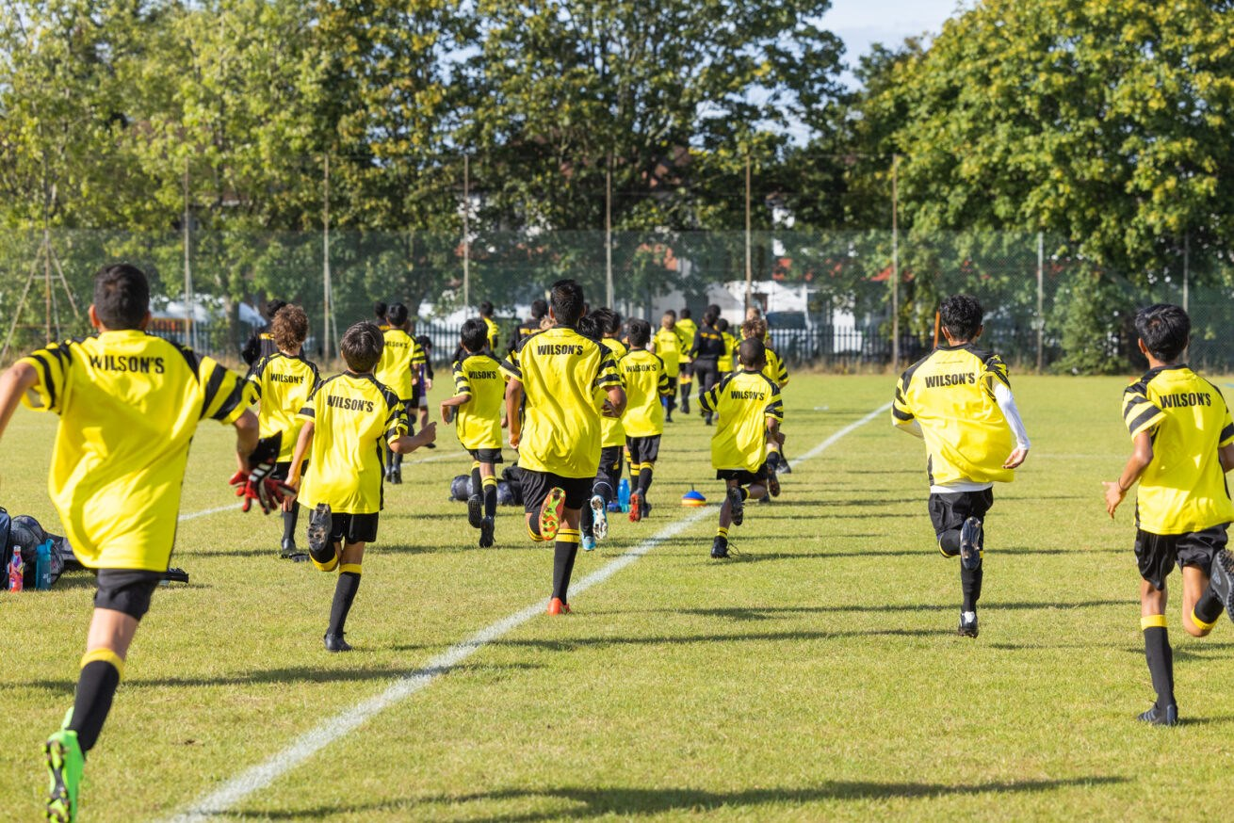
We are proud to report Wilson’s was recently awarded Secondary School of the Year 2024 in The Sunday Times Parent Power Schools Guide.
The Sunday Times Parent Power Schools Guide is widely acknowledged as an authoritative survey of the UK’s best schools, taking into account a wide range of features of each school, as well as examination results.
Ranking as the best secondary school in the country - across all independent and state schools - is a huge achievement, and a testament to the dedication of our brilliant staff and the character of our hard-working students.
The judges were particularly impressed by the breadth of excellence being displayed across all aspects of the school's operations. Wilson's response to the pandemic was also warmly commended.
Commenting on the achievement, Nathan Cole, Headmaster, said:
"These pupils were young during the pandemic but maintaining standards around welfare and academic lessons in the way we did benefited them. The school took delivery of the curriculum (online during lockdowns) very seriously, including games lessons on Zoom!”
Everyone involved with the school can take enormous pride in this achievement - and particularly in what it says about the resilience of the Wilson’s community!
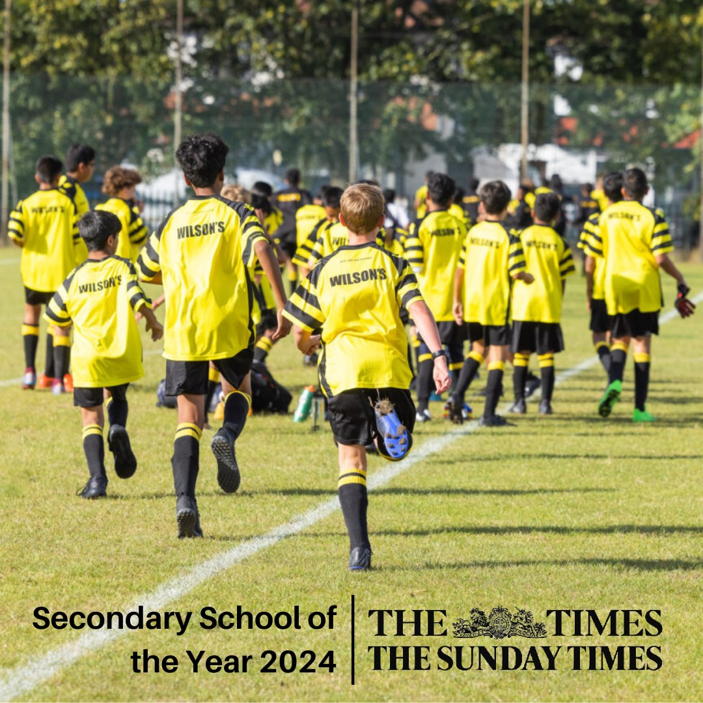
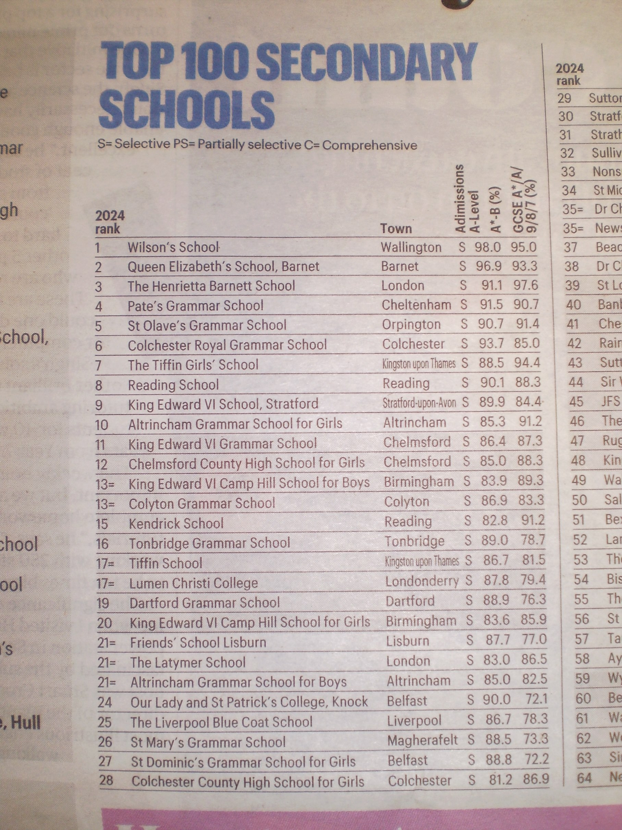

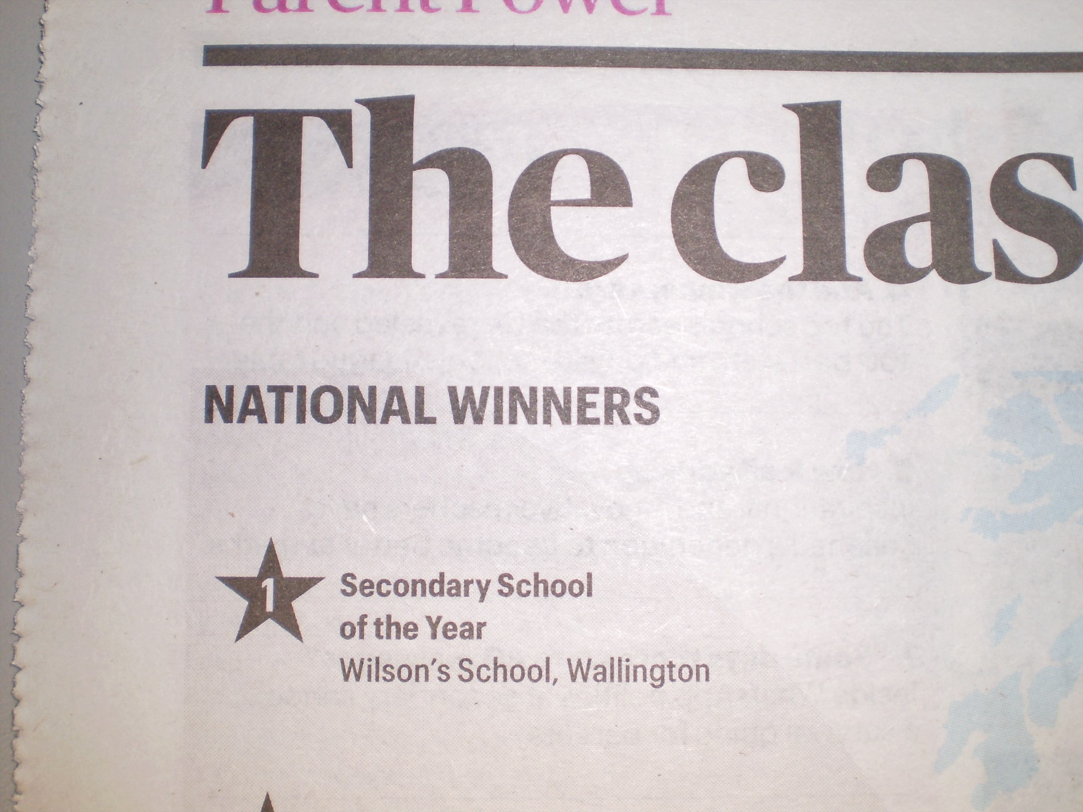

Wilsonian wins at Wimbledon!


Huge congratulations to Mark (Year 10) who won the Boy’s 14 & Under Singles title in straight sets at the Wimbledon Tennis Championships in July!
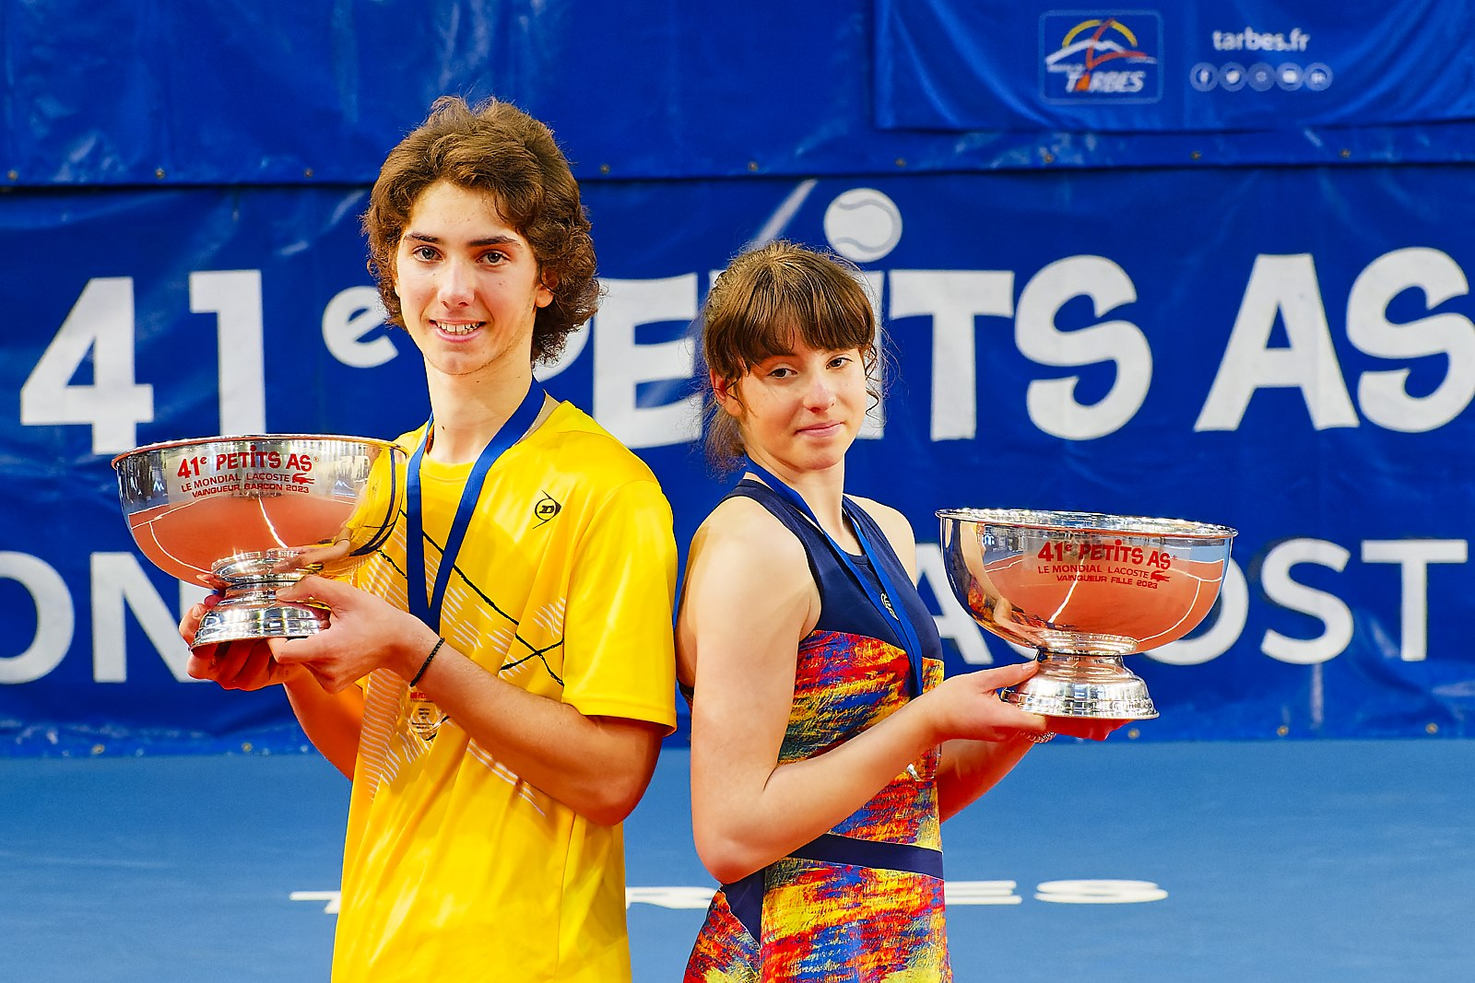
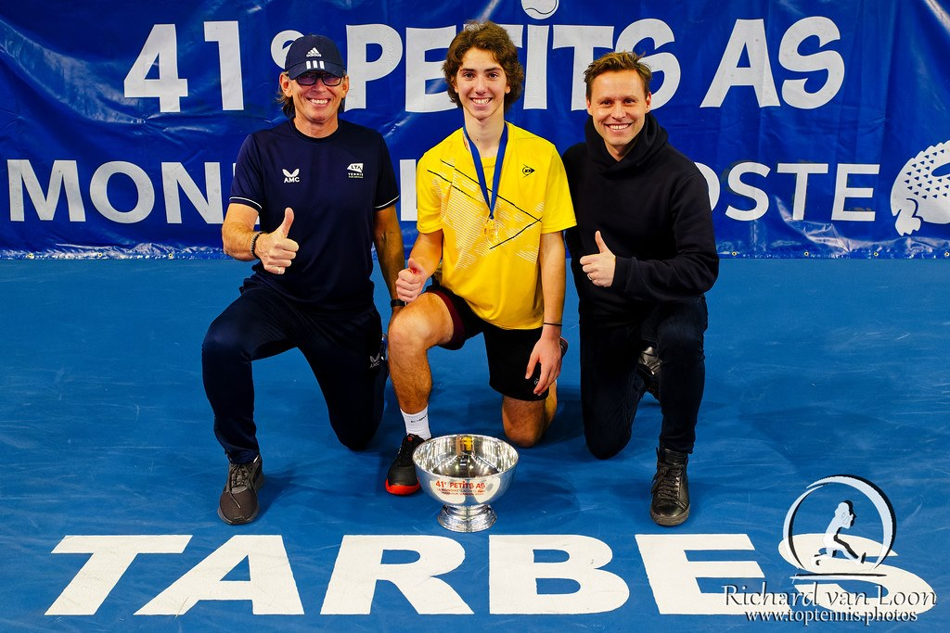
It has been a remarkable year for Mark, who also won the highly-regarded Les Petits As tennis tournament in February.
Held in Tarbes, France, Les Petits As is the most prestigious U14 tournament in the world, with several of its previous champions going on to become grand slam winners, including Rafael Nadal.
We wish Mark the very best as he continues to develop his outstanding tennis skills as a Wilson’s student!

Alumnus of the Term: Matthew Stratford
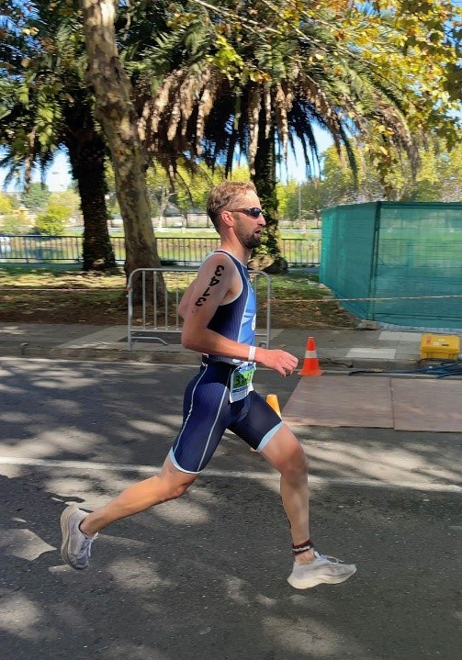
We were delighted to be able to catch-up with Old Wilsonian, Matthew Stratford, following his win in the recent World Triathlon Champs. Matthew says...
"My recent victory in the 40-44 age category at the World Triathlon Championships can certainly be credited in part to my time enjoying multiple sports at Wilson’s School during the 1990s.
I was fortunate to attend Wilson’s when there was a swimming pool and took advantage of the coached swim sessions (by Jackie Letts) which took place before school three times a week.
Rather than my motivation being fitness-driven, it was largely a means to avoid the walk to school - my Dad (Mr Stratford - Head of Games at the time), was a very diligent swimming attendee and with or without me he was leaving at 7.30am!
As well as swimming, I also enjoyed cross-country and won a few County Championships under the guidance of Mr Molyneux. All these years later, I'm glad to hear he's still coaching Badminton at Wilson's!
Following school, I studied Civil Engineering at University in Nottingham, where I still live and work as a director at a local consulting engineering practice, fitting training around the structural design of buildings.
Too much running caused a niggling hamstring injury in my late 30s. The need for a lower-impact sport led me to try cycling and latterly Triathlons. I entered some local races, initially making some rookie mistakes, but eventually found some success and things led on from there.
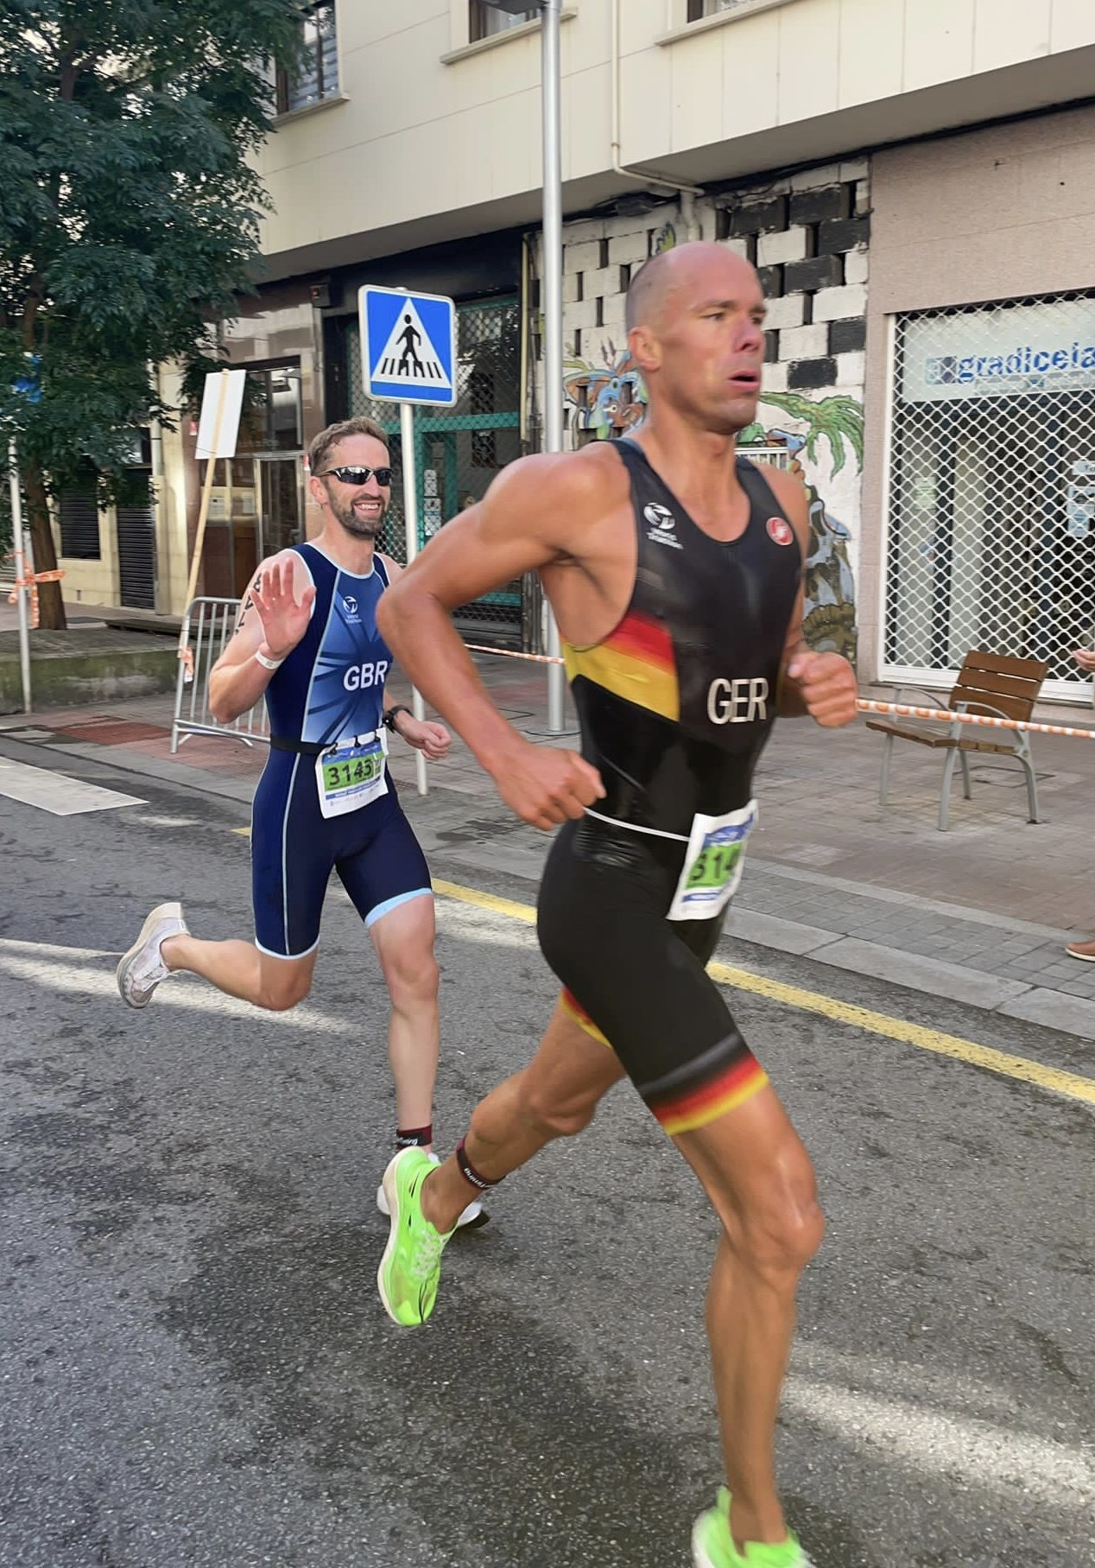
Winning the British Triathlon Championships for my age group qualified me to represent Team GB at the recent World Championships. The event was held in the scenic city of Pontevedra, Spain – an undulating course - and a tough German competitor pushed me hard, but a final decisive effort was enough to secure the win to become World Champion.
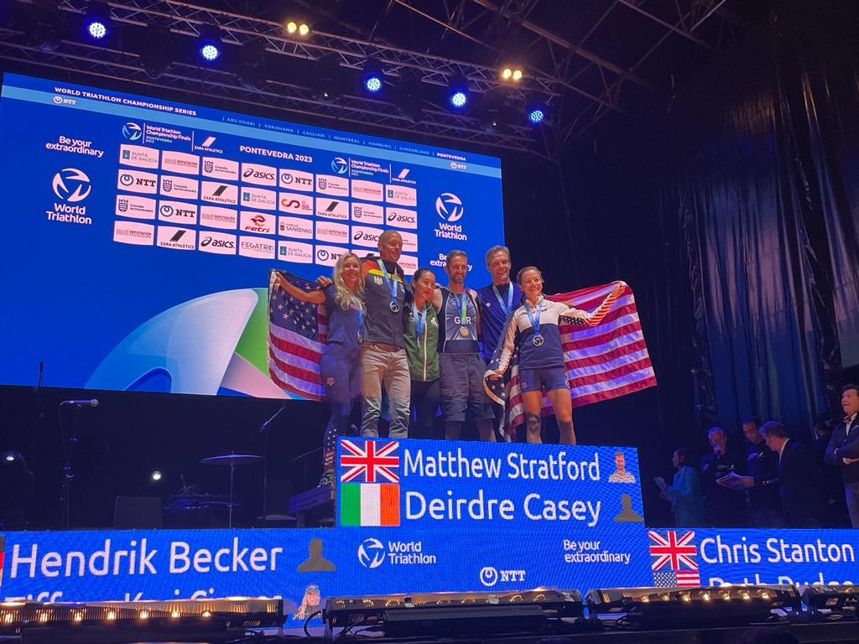
1 - Stratford wins Gold!
I look back at my time at Wilson’s with great fondness and I’m proud to say I’m an Old Wilsonian – along with my dad and brother, Daniel.
It’s impressive how well-known the Wilson’s name is throughout the country, and I’m really pleased to see that the school continues to thrive!"

OWFC vs School fixtures take place
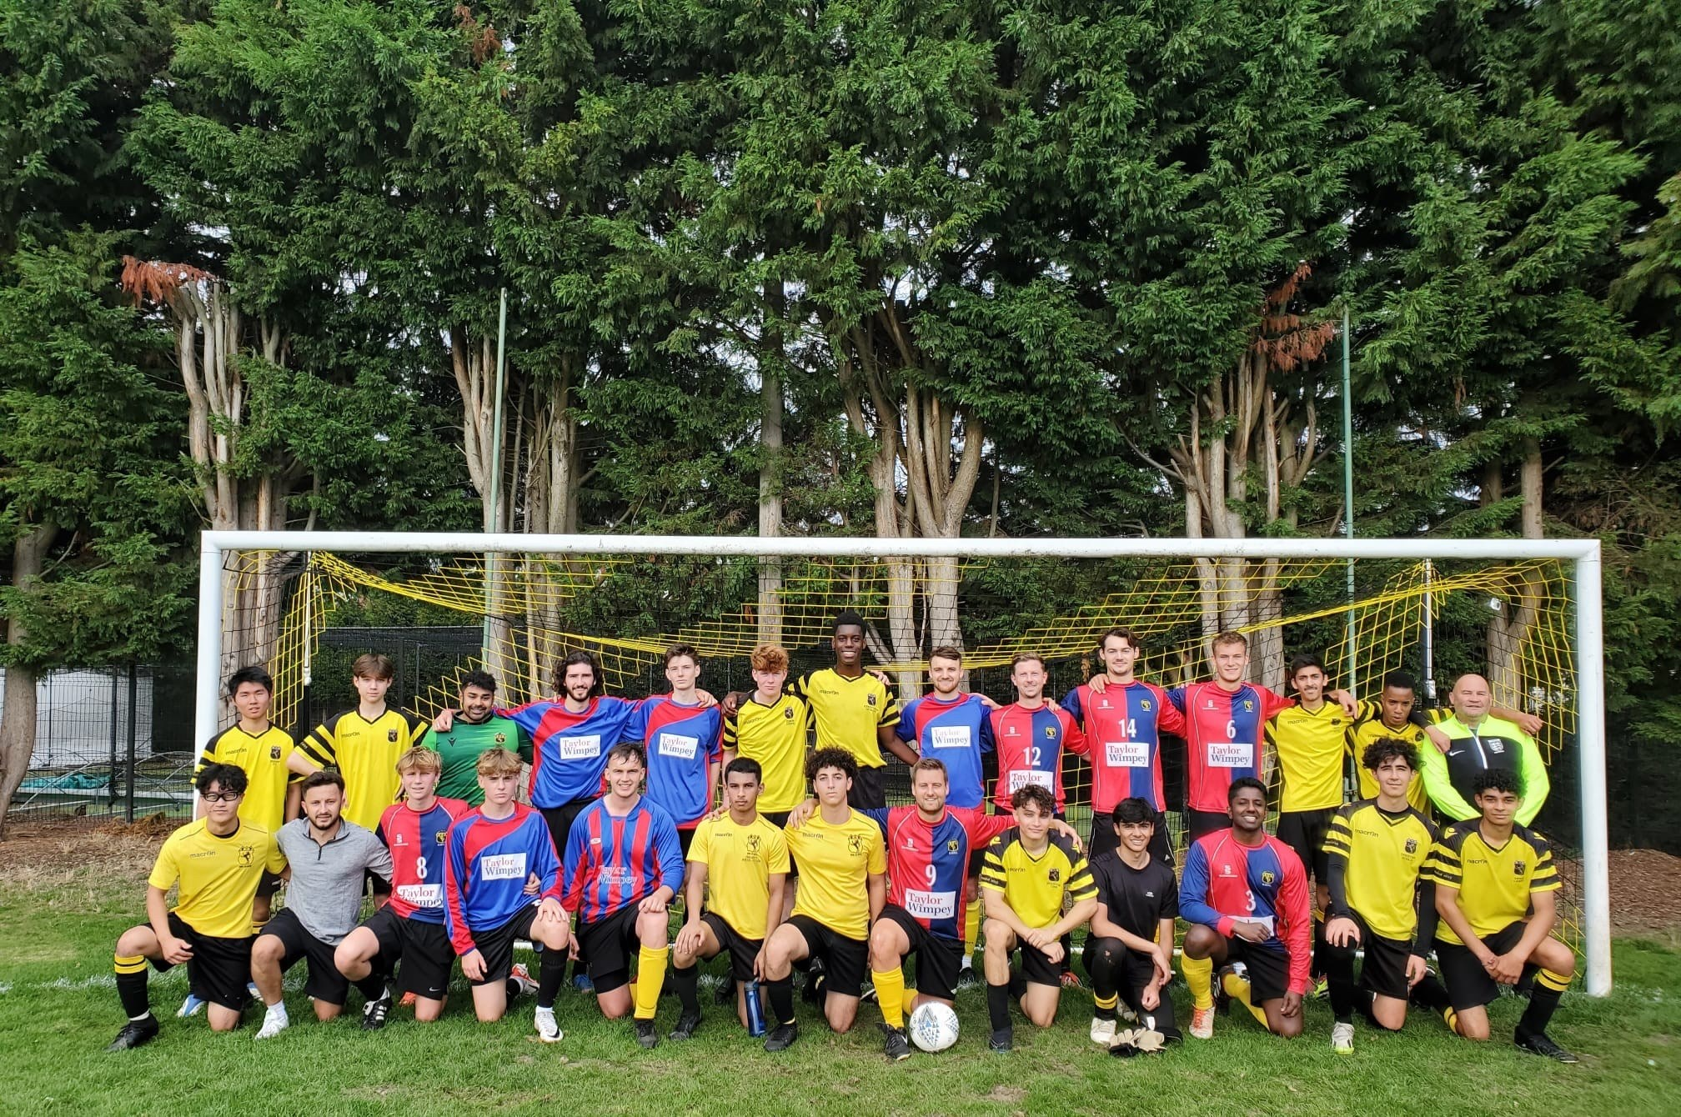
On Saturday 30 September, our annual block of football fixtures against the Old Wilsonians Football Club took place at Hayes Hill.
Four entertaining games between current students and OWs saw 24 goals scored - Wilson’s 2nd XI (pictured) securing a famous 5-2 ‘away’ victory!
Thanks - as always - to the Old Wilsonians Football Club for hosting the games, and for welcoming Wilson’s boys to the club so warmly.
We look forward to the continuing success of the OWFC, as Wilson’s alumni continue to take the opportunity to represent Wilson’s on the football pitch long after their school years have finished!

Battle Of The Bands 2023

The annual Wilson's 'Battle Of The Bands' competition took place on 12 October.
The brainchild of music teacher, Mr Kramer, the 2023 event saw sixteen bands of different styles and sizes take to the stage of the John Jenkins Hall to do battle and rock the crowd!
The panel of judges, comprising teachers and students, was hugely impressed by the musical talent and showmanship on display, and took quite some time to deliberate. Eventually, the results were as follows:
Winners of the Junior category: 'AB/CD'
Winners of the Senior category: 'Censored'
Congratulations to everyone involved, particularly Mr Kramer for organising the event, and Mr Burton for capturing the fantastic pictures on the night!







For a full report, penned by Alexander (Year 10), who is participating in the BBC's Young Reporter Scheme - click here.

Benjamin Room Inauguration
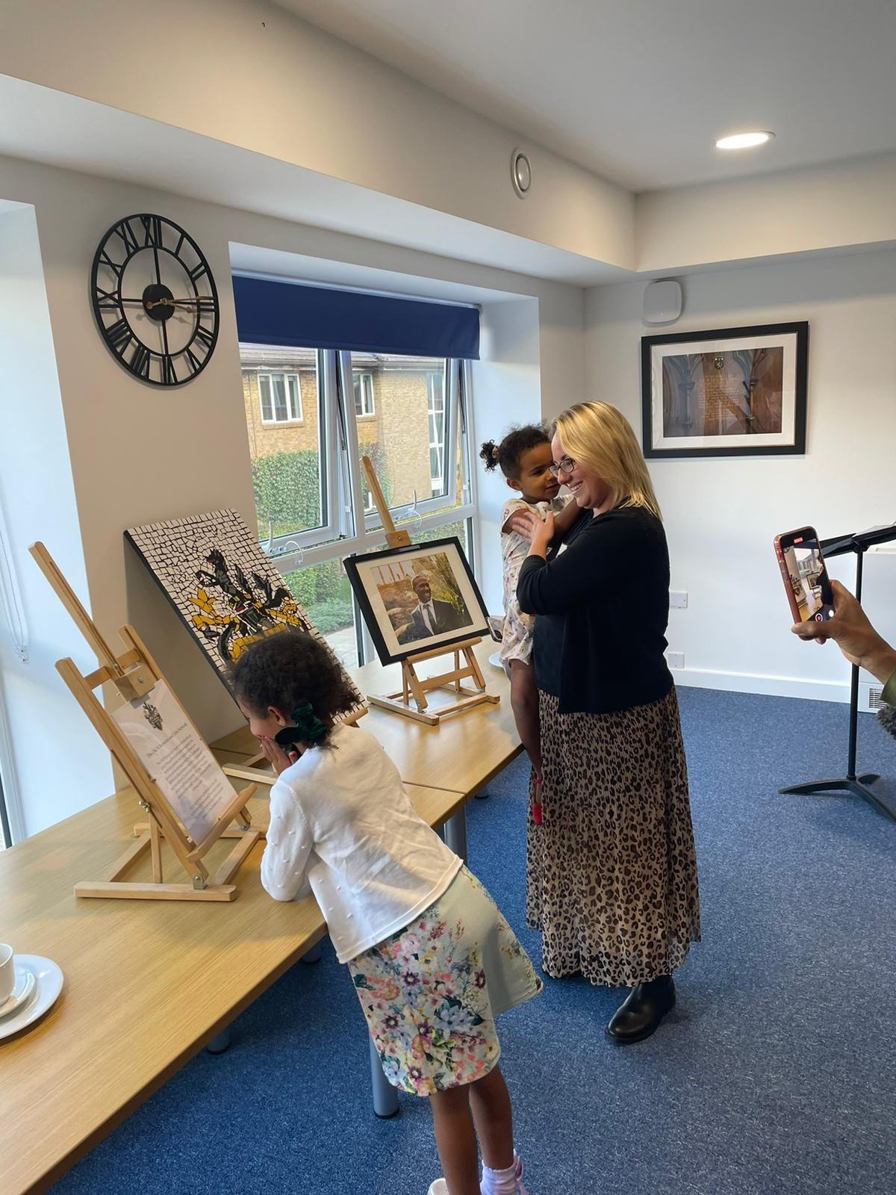
On Saturday 14 October, a select group of guests assembled at the school to inaugurate the Benjamin Room in our new Wellbeing Centre.
The Benjamin Room was named in memory of much-loved OW, Kirk Benjamin, who died in 2019. We were delighted to welcome Kirk's widow, Sophie, to the event, as well as their two daughters, Sienna and Isla.
Also present were a number of prominent members of the Old Wilsonians Association (OWA) who, with others, had raised over £3,000 for the equipping of this new facility. That such a significant amount was raised is a testament to Kirk's popularity and the respect in which he was held by his fellow alumni.


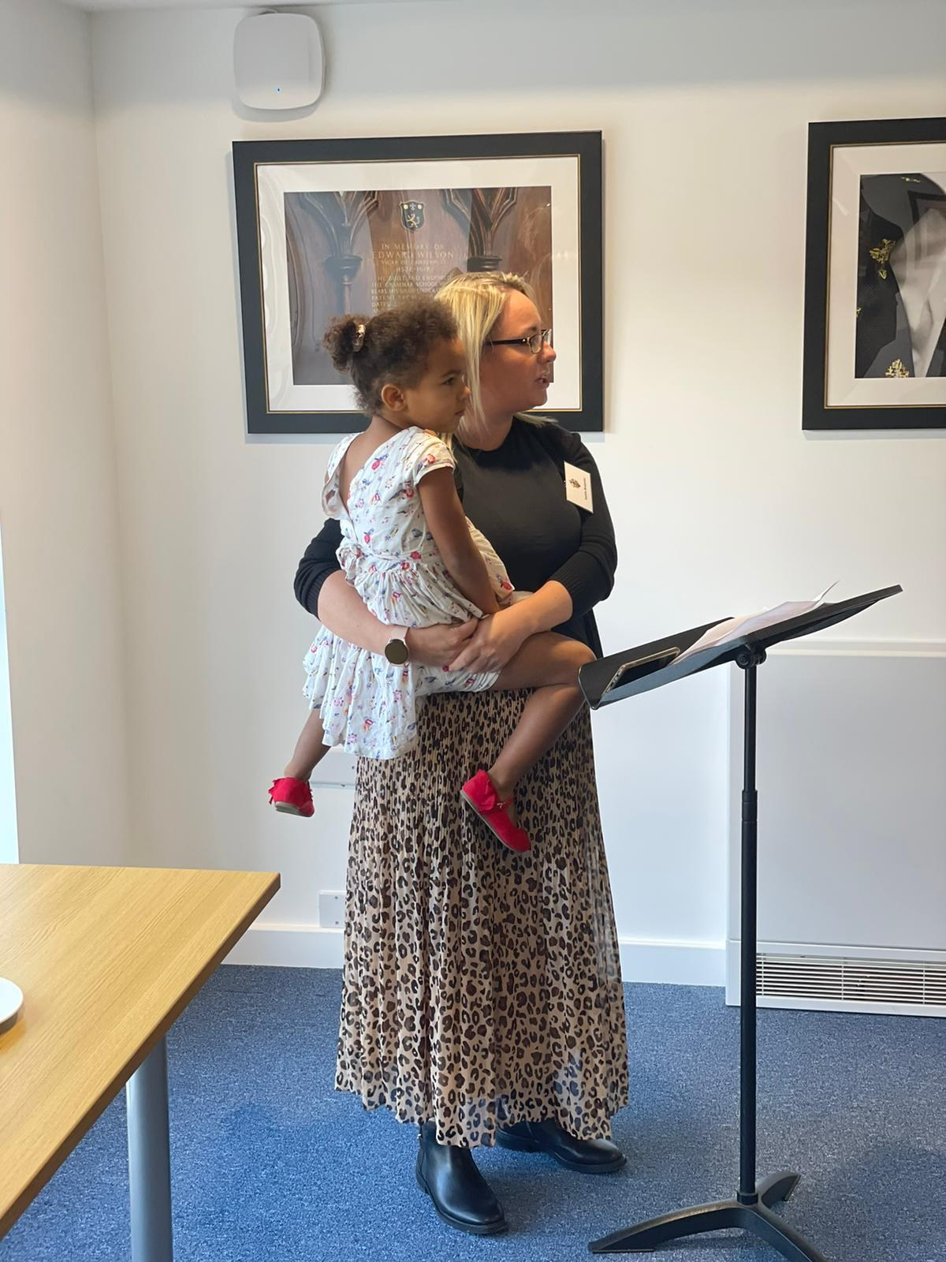
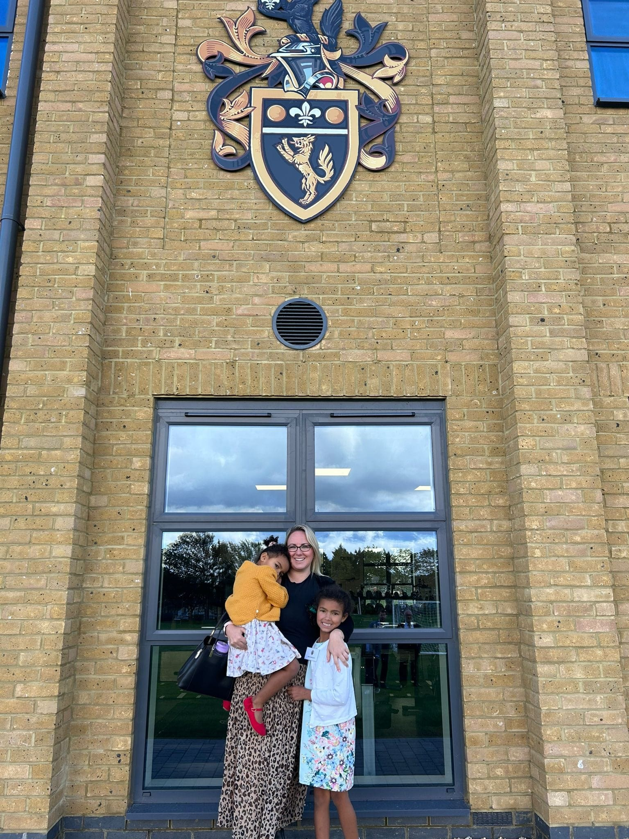
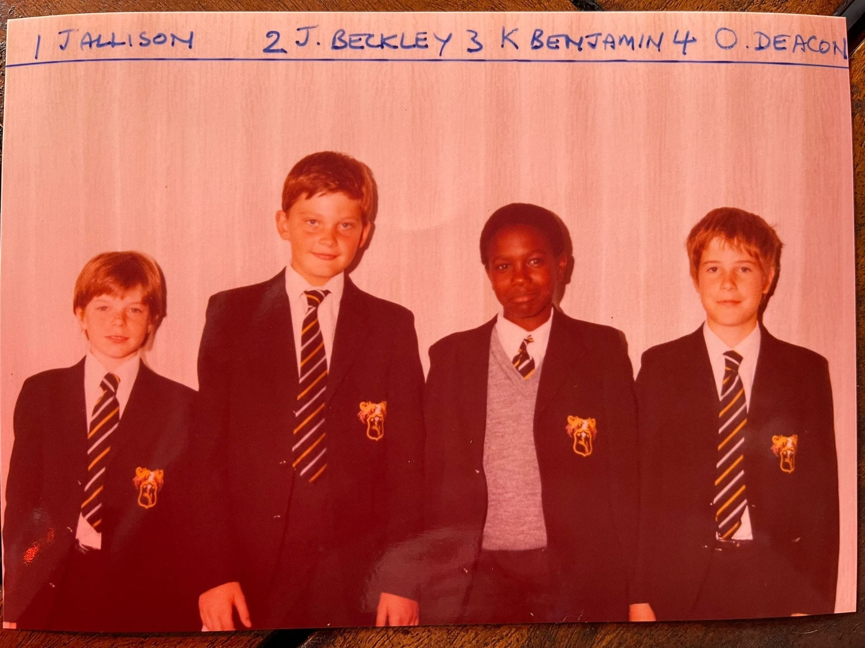
The Benjamin Room is a key part of our new Wellbeing Centre, specifically dedicated to protecting and enhancing the welfare of Wilsonians for years to come.
If you're keen to support our development plans related to wellbeing, please contact Will Straw via email at was@wilsonsschool.sutton.sch.uk

Join 'The Edward Wilson Society'

A key part of our Legacies for Wilson's campaign, the Development Office are delighted to have launched ‘The Edward Wilson Society’.
By remembering Wilson's in your will, you can ensure the school continues to move forward with confidence. If you are interested in making a legacy to Wilson's, please read the brochure here and follow the instructions included within.
We are planning to host our first legators' event soon – a lunch for members of The Edward Wilson Society – who have made a legacy pledge to the school.
If you have any questions related to legacy giving, please contact the Director of Development, Tim Edge, via email at TE@wilsonsschool.sutton.sch.uk who will be delighted to speak with you!
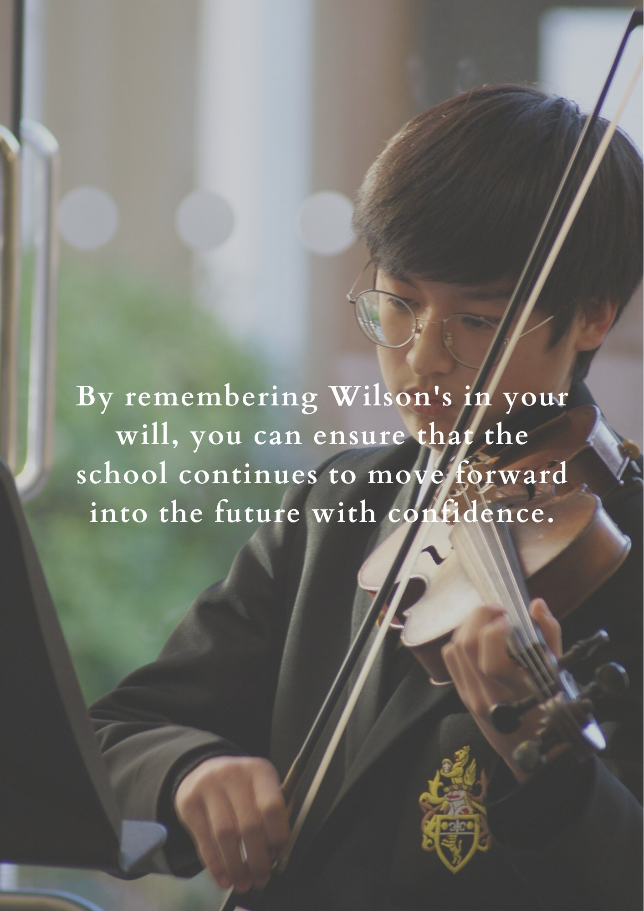
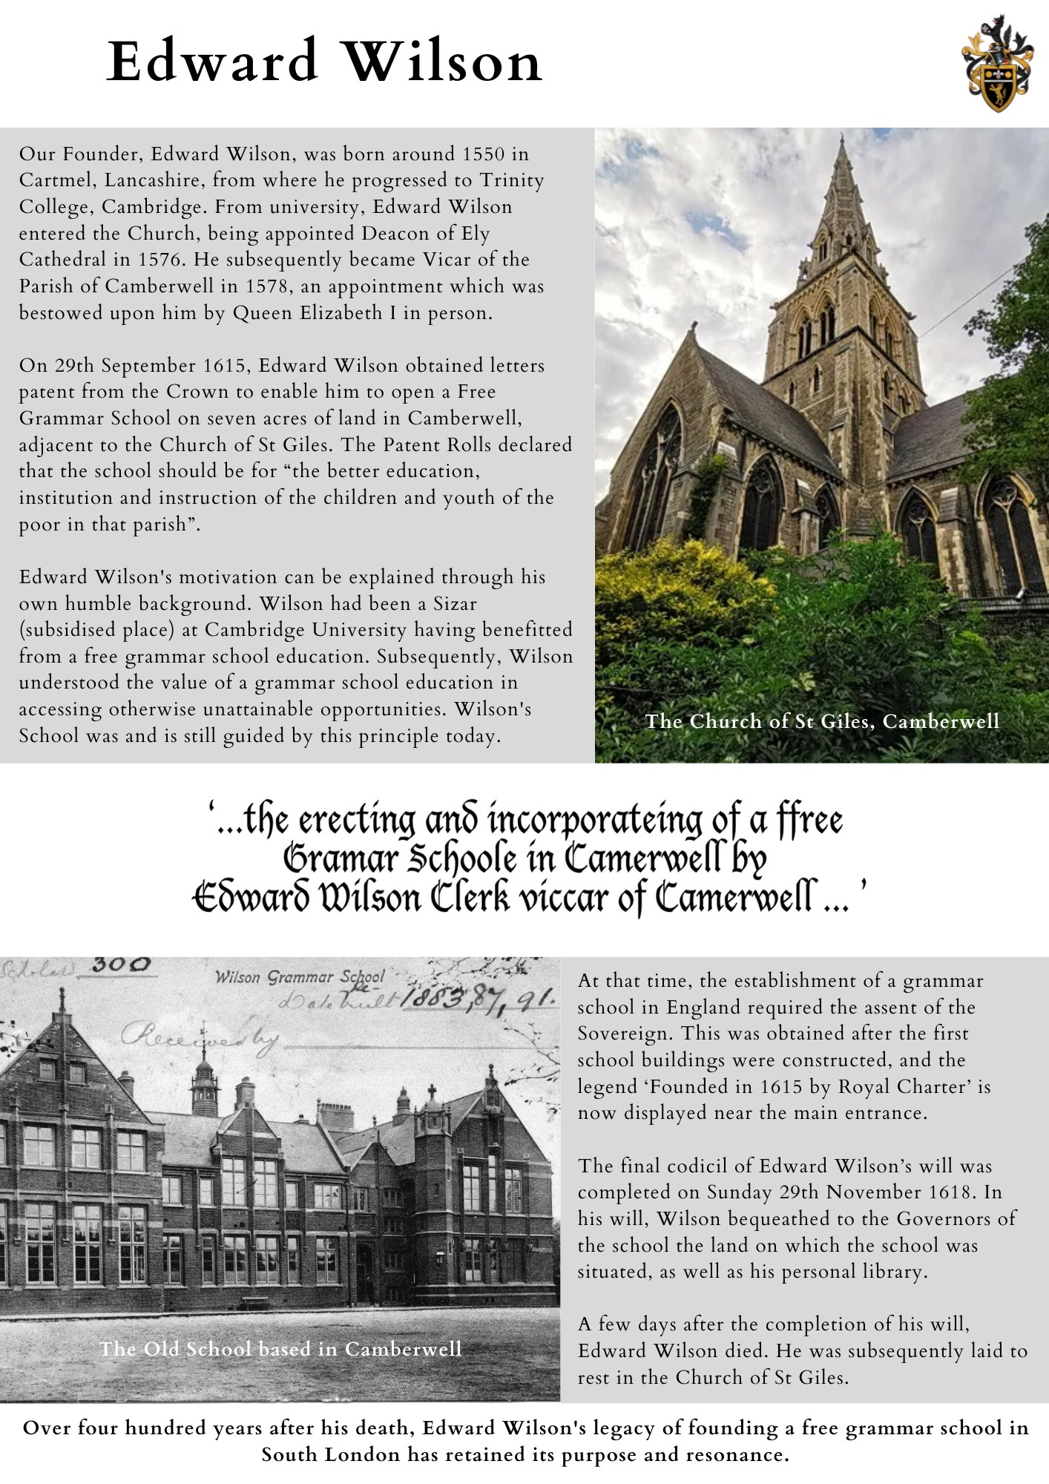
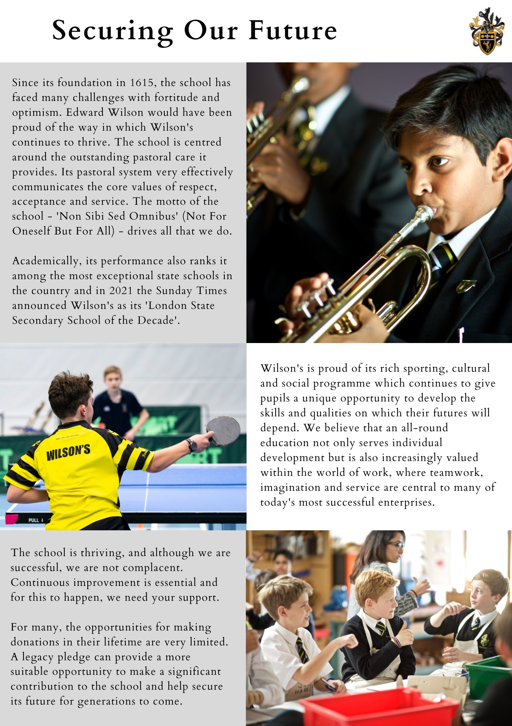
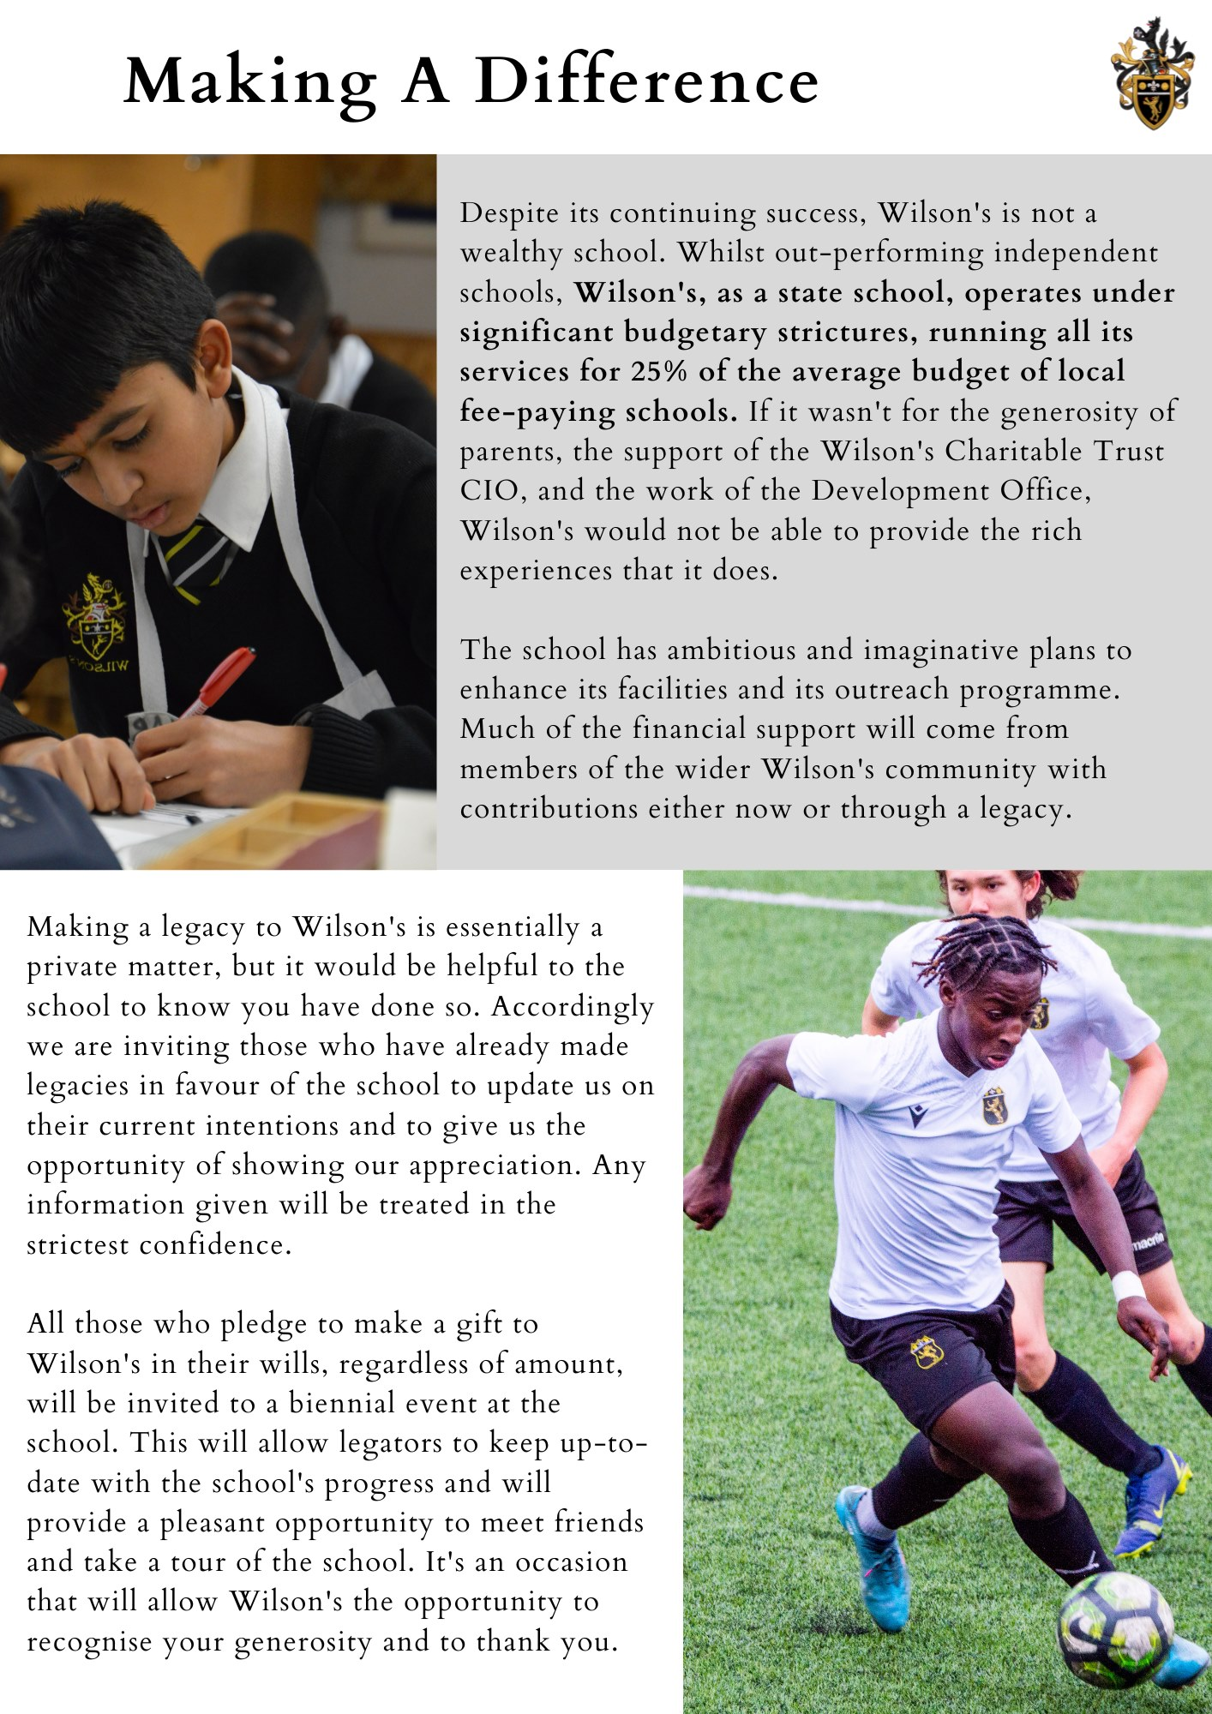
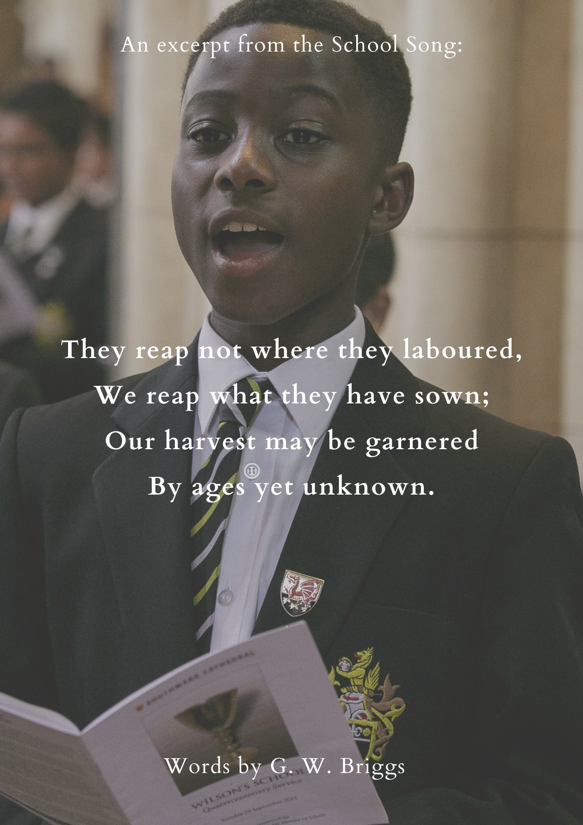

Here We Go: OW Turns Pro
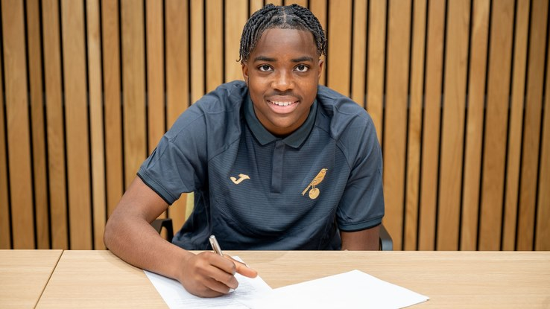
In July, we were delighted to see Dubem Eze, Old Wilsonian, sign a professional contract with Norwich City Football Club.
Dubem excelled as a footballer at Wilson's before leaving the school in 2016, swapping our well-known black and yellow shirt for the yellow and green of Norwich.
We wish Dubem the very best of luck for the remainder of the Championship season with the Canaries!

Support Us!
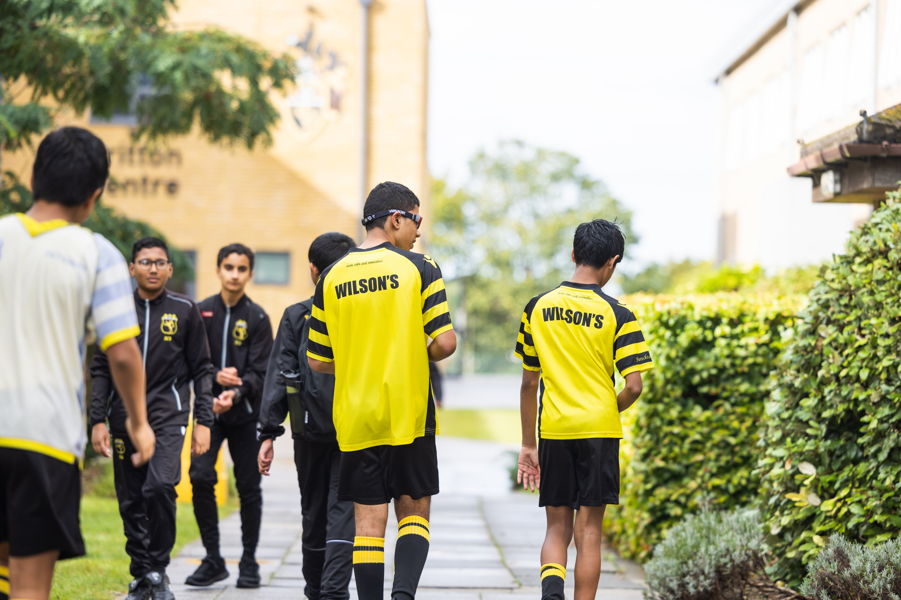
The reality is that, despite its continuing success, Wilson's is not - and never has been - a wealthy school.
Wilson's is given just £15 per day by the government to educate each pupil. This is expected to cover all costs - teaching, heating, co-curricular activities, books, sports equipment, payroll for all teaching and support staff, and a great deal more.
In comparison, local independent schools are able to spend on average £55 per day on each of their pupils.
To enable Wilson's to maintain and enhance the excellence that it offers to all, we need your financial support.
Ways that you can support us include:
- Donating a regular monthly amount to the school. You can contribute via PayPal Giving quickly and easily at the link here.
- Making a more significant one-off gift, which may bring with it the possibility of a naming opportunity.
- Joining 'The Edward Wilson Society' and making a legacy to Wilson's.
For further information on all aspects of giving to Wilson's, please contact the Director of Development, Tim Edge, via email at TE@wilsonsschool.sutton.sch.uk who will be delighted to answer your questions!

Developing Wilson's
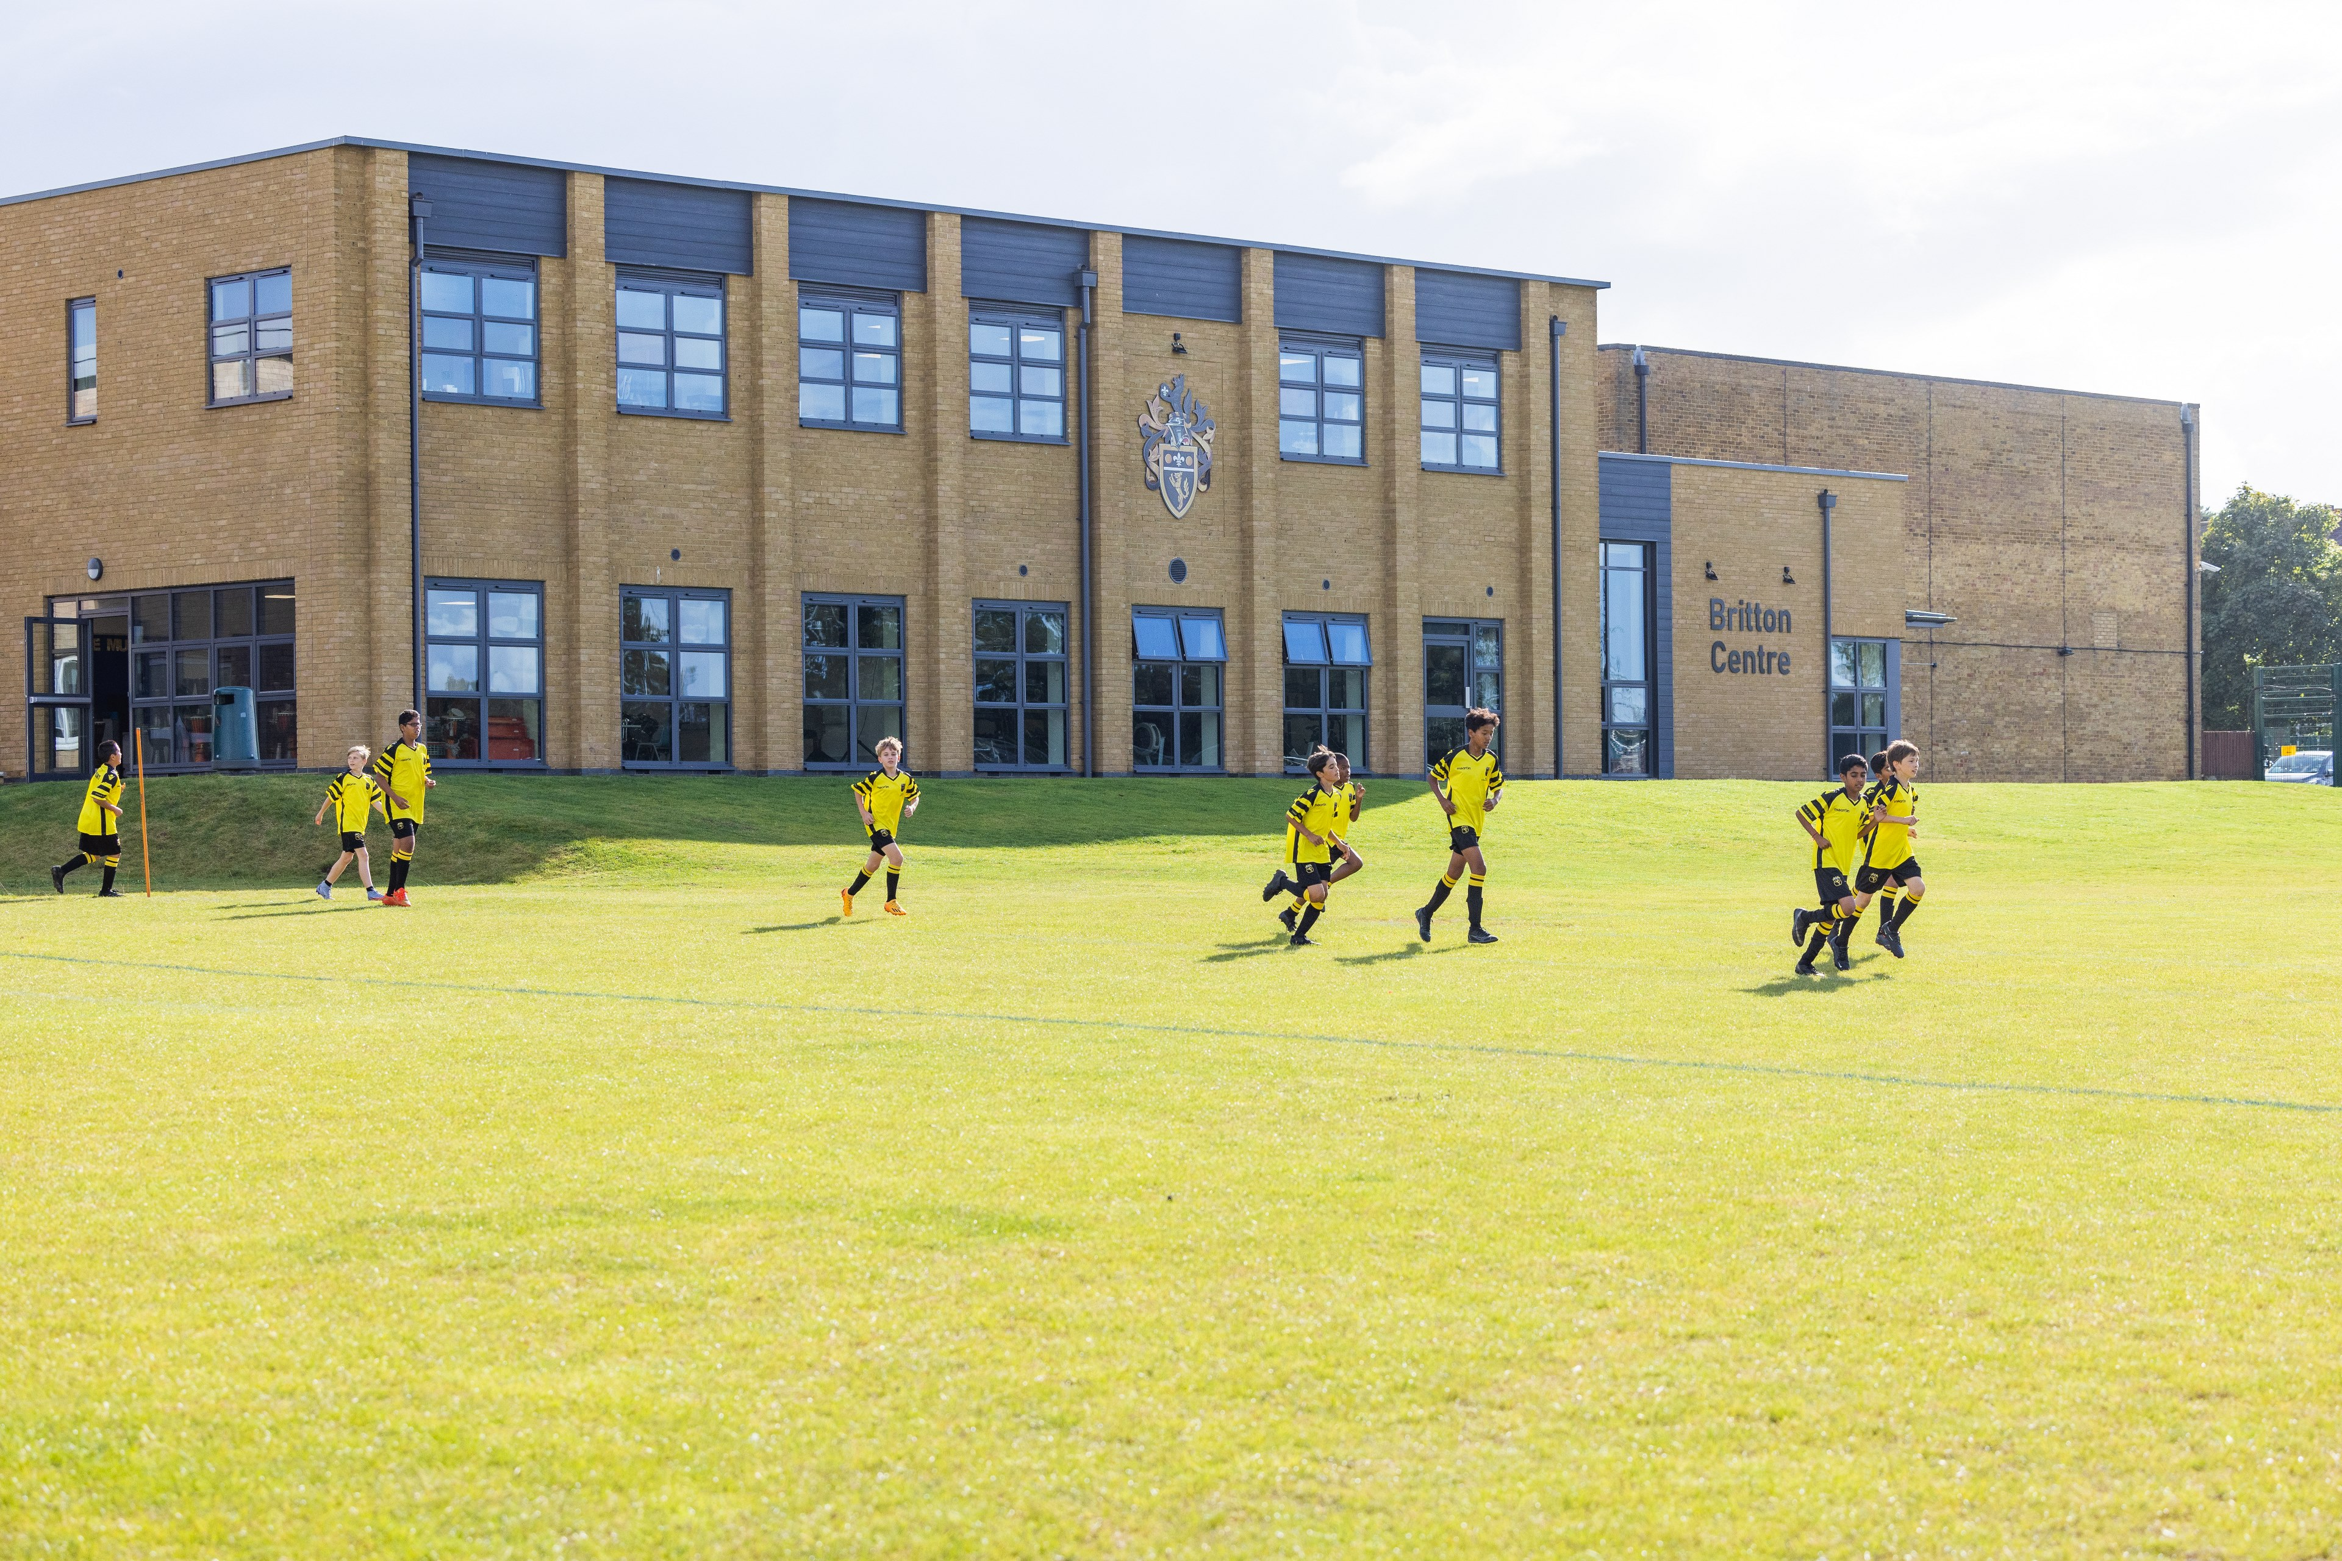
Following contributions from well over 500 individual donors, the Britton Centre - officially opened by Princess Eugenie in January 2023 - has dramatically improved our music and sports facilities.
Featuring a brand-new Recital Room, nine music practice rooms, and a state-of-the-art fitness suite, our donors have directly improved the provision of education at Wilson's for current and future generations.
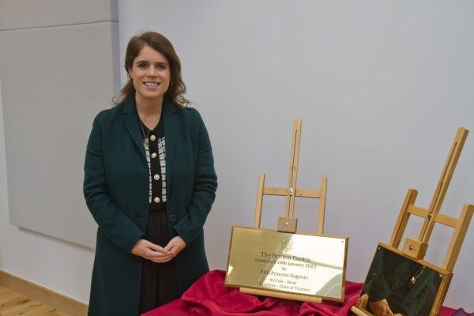
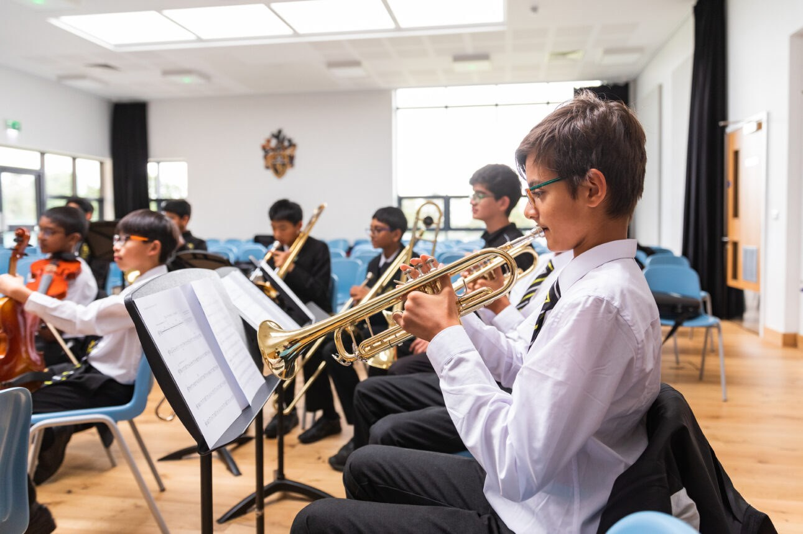
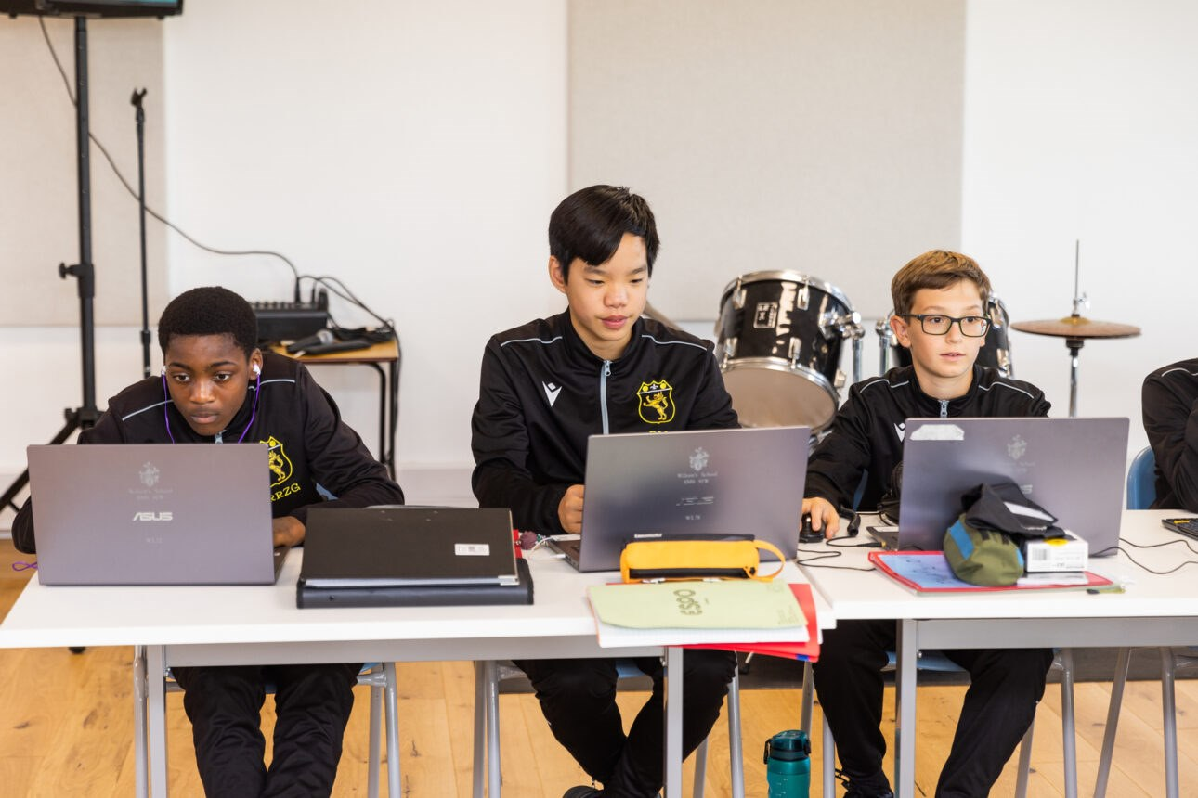
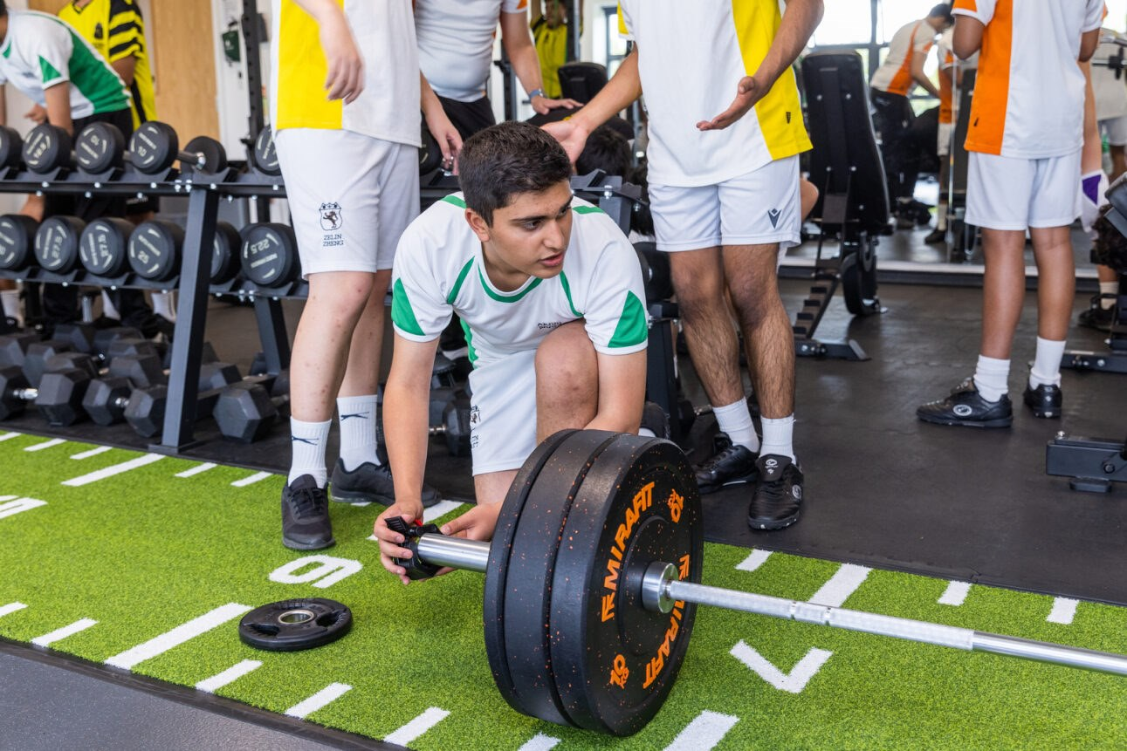
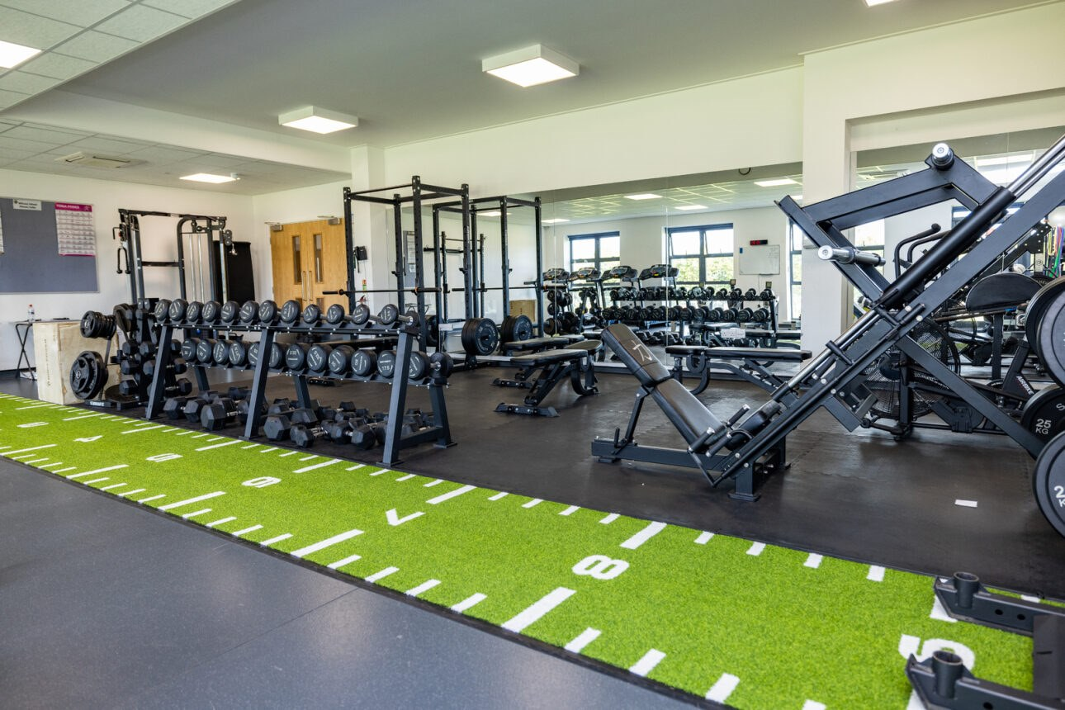
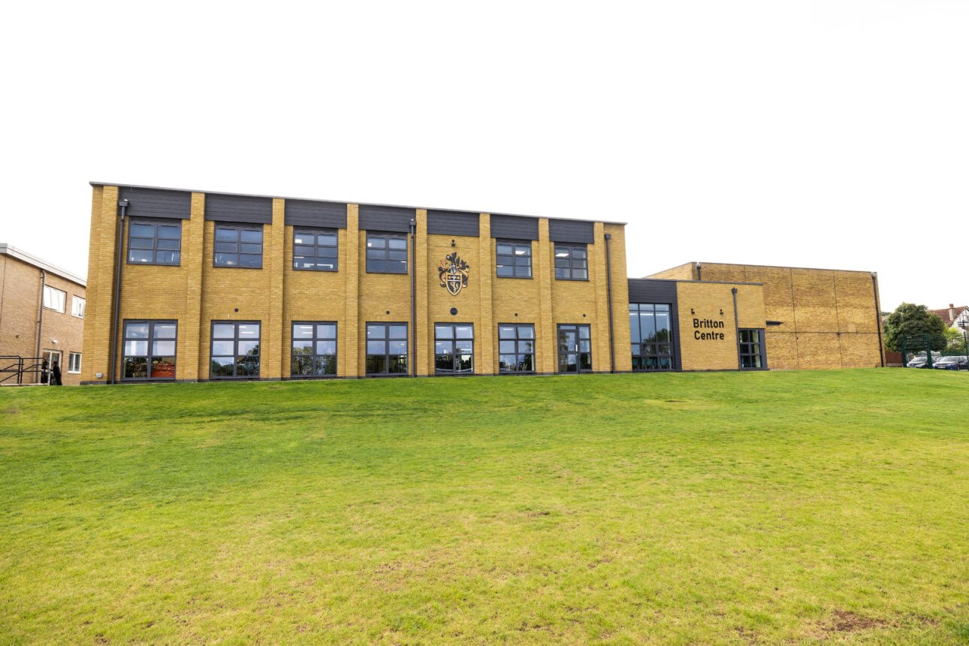
Beyond the Britton Centre, we have also succeeded in establishing an entirely new Wellbeing Centre at Wilson's.
The establishment of a dedicated space for our Wellbeing Lead, Safeguarding Team and Wellbeing Prefects to work from has ensured the welfare of everyone at the school is at the forefront of our thinking, and will positively impact Wilsonians for many years to come.
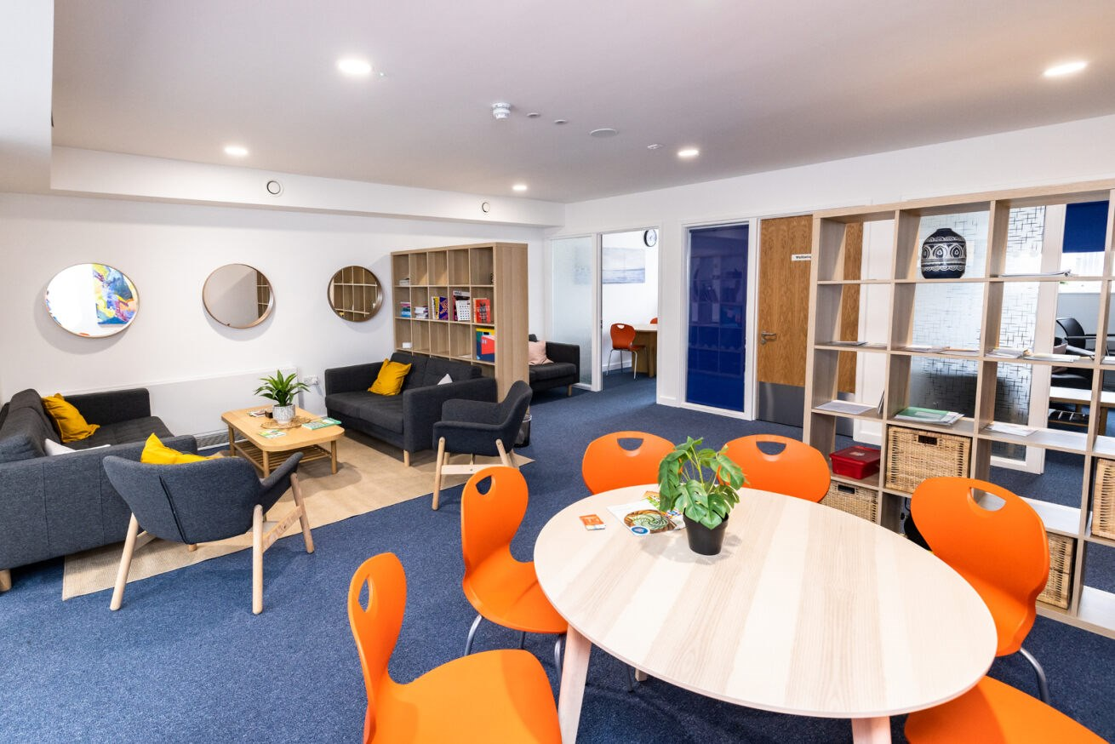
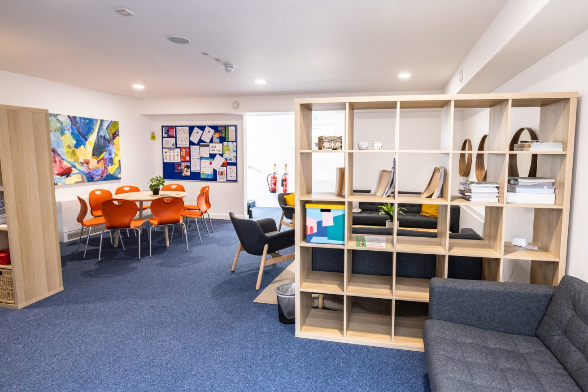
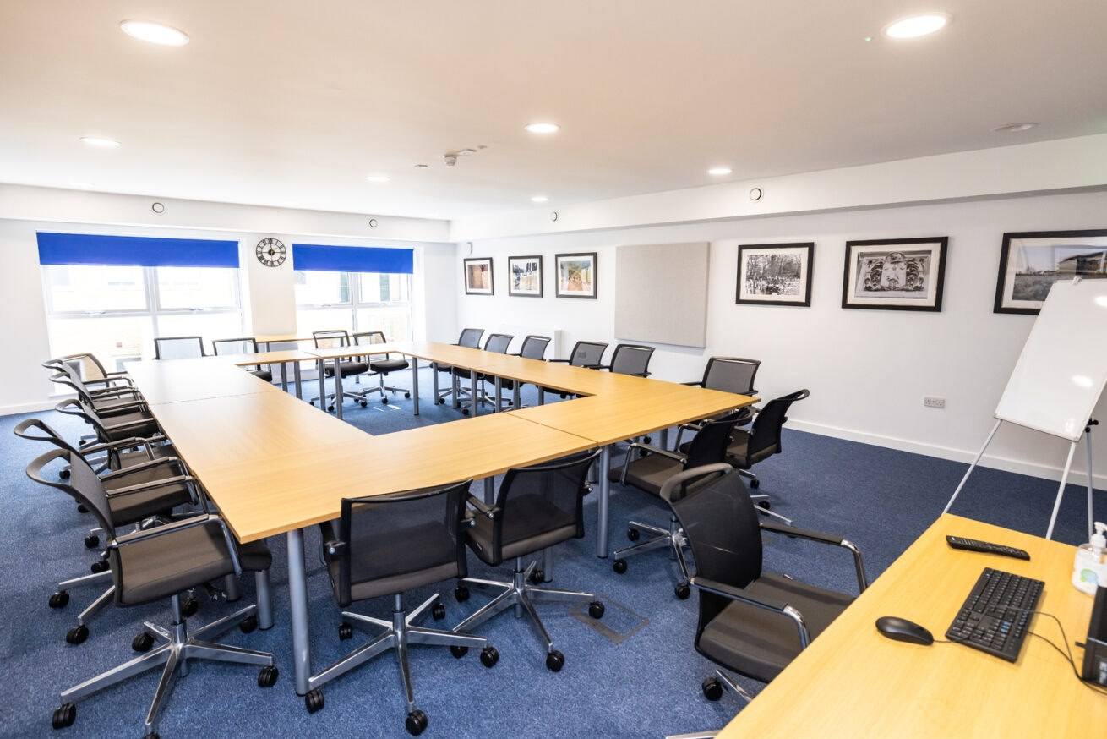
Wilson's would not be able to offer what it currently does without the support of our community.
If you are able to step up and support the school financially - backing us to achieve our ambitious development plans - please contact the Director of Development, Tim Edge, via email at TE@wilsonsschool.sutton.sch.uk

Upcoming Events
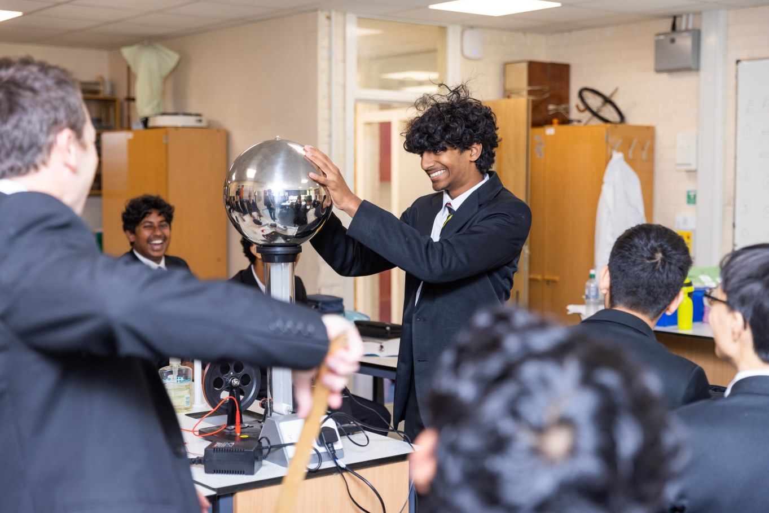
The Development Office, with the OWA, is planning several events including a Camberwell Drinks Party in March 2024 and an Alumni Dinner at the school in September. We will also be hosting a Science Symposium at the school in the spring term to launch our fundraising for new science facilities.
Further details of all these events will follow on social media soon!

Stay Connected
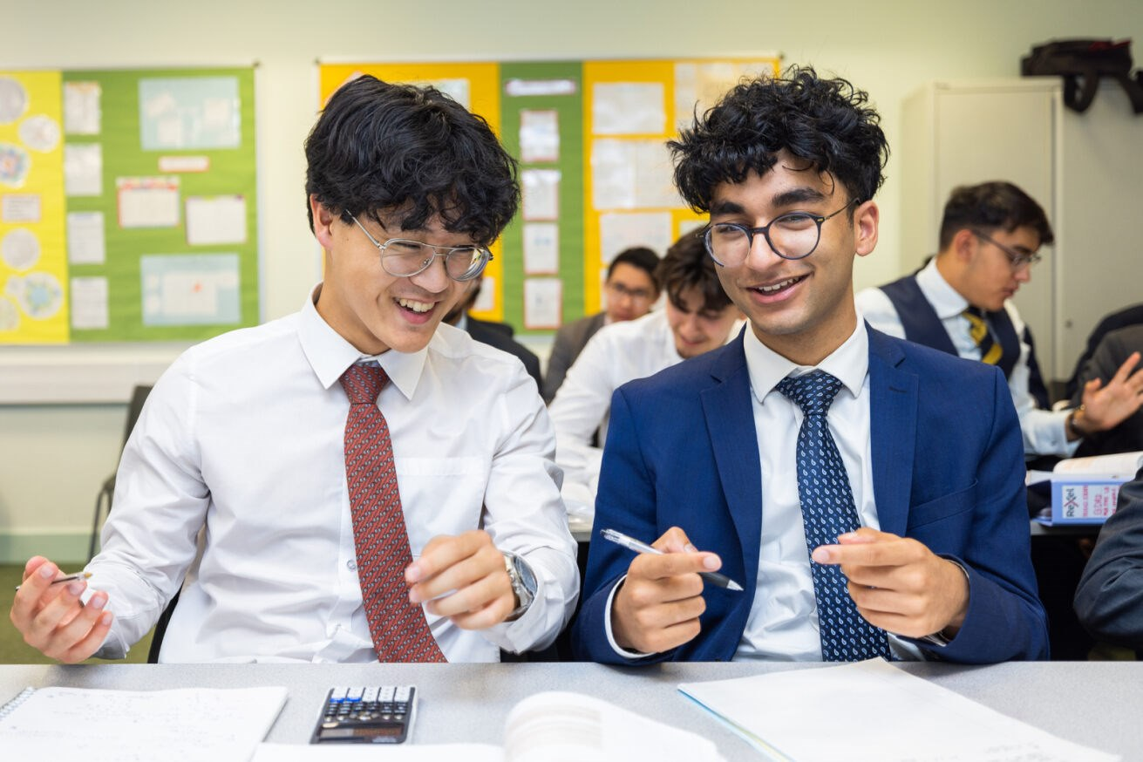
The Wilson's Alumni Network operates across social media. The key links are:
- Follow Wilson's School on Instagram. This will also enable you to read all the exciting news stories from our website as they are published.
- Connect with, and follow, Wilson's School on LinkedIn. If you are an Old Wilsonian, add your dates at Wilson's to the Education section in your profile and your email address to the contact details section.
- Join the Wilson's Alumni Network on Facebook.
- Follow the Wilson's Development Team on Instagram.

Get In Touch
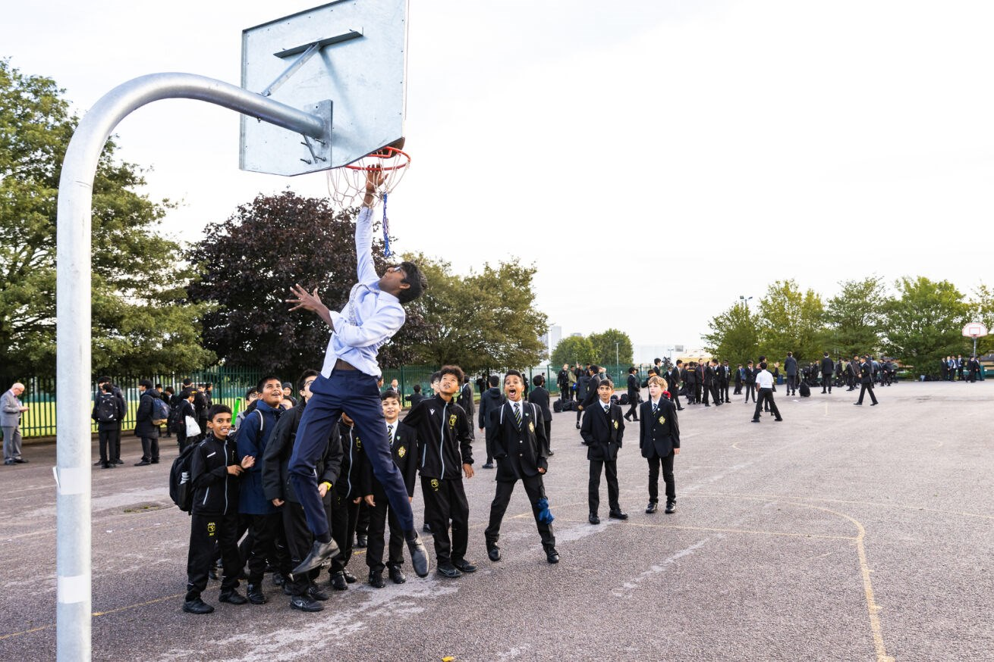
It's always great to hear from Old Wilsonians and friends of the school. If you have any ideas for the next edition of Wolf Salient - or think you can support the school - please get in touch!
- To call the Development Office, dial 0208 773 7684 to speak with Tim Edge, Director of Development. You can also contact Tim via email at te@wilsonsschool.sutton.sch.uk
- To share your ideas for the next issue of Wolf Salient or to direct alumni queries to the school, contact Will Straw - Assistant Director of Development and author of this newsletter - via email at was@wilsonsschool.sutton.sch.uk
- All information related to the Development Office can be asked on the school website here.

